CAPTURING AND ANALYSING PACKETS USING WIRESHARK TOOL

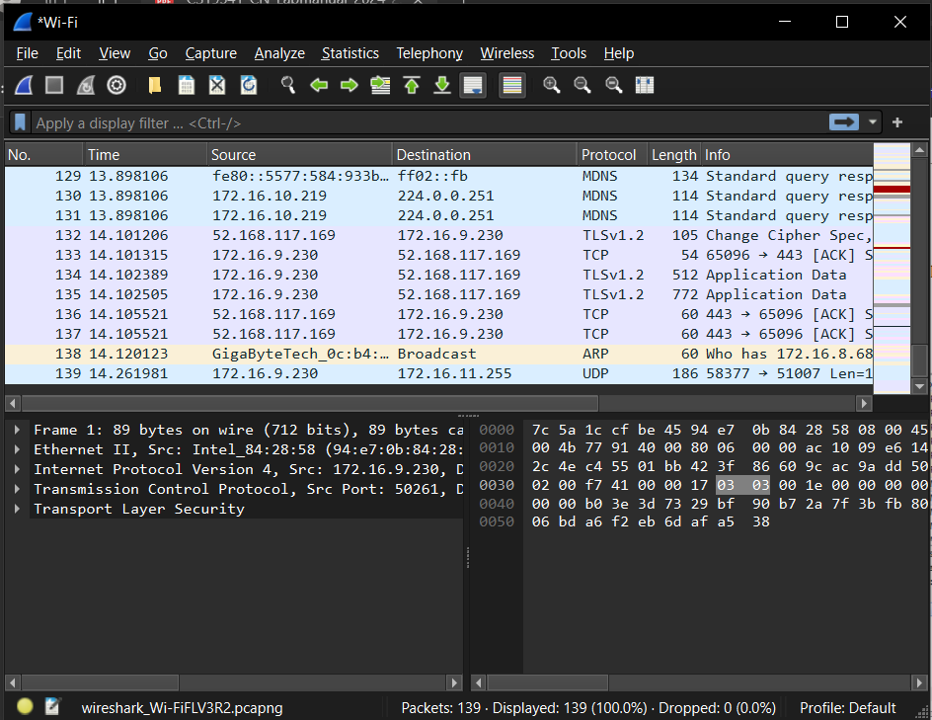

1. Create a Filter to display only TCP/UDP packets, inspect the packets and provide the flow graph

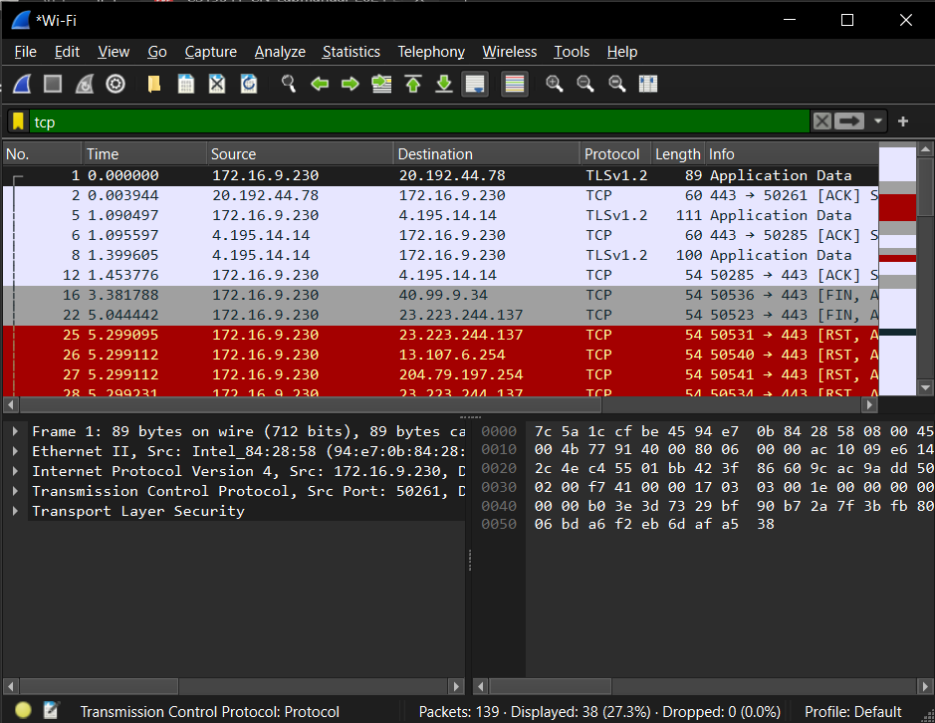

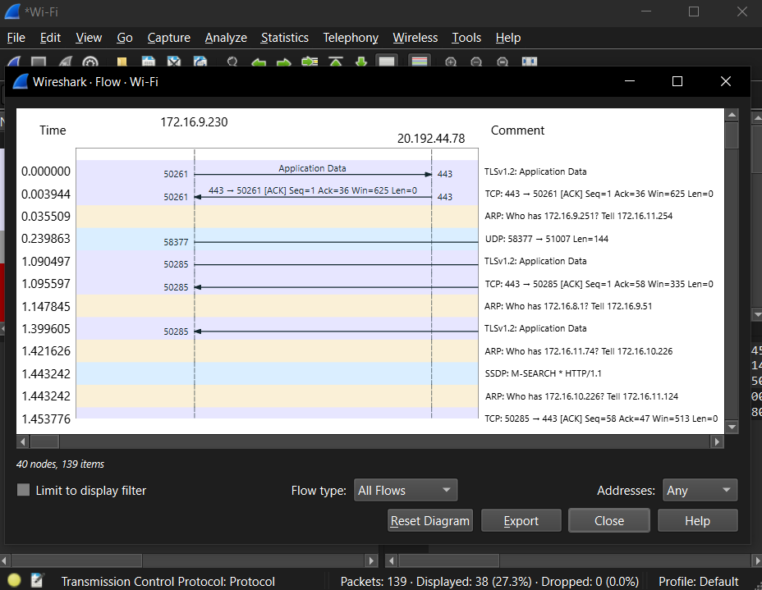

2. Create a Filter to display only ARP packets and inspect the packets

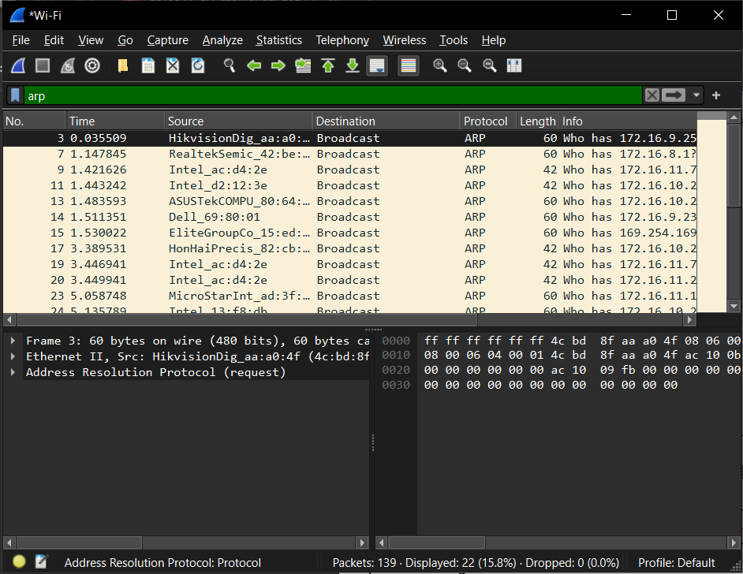

4. Create a Filter to display only HTTP packets and inspect the packets Procedure.

5. Create a Filter to display only IP/ICMP packets and inspect the packets.

